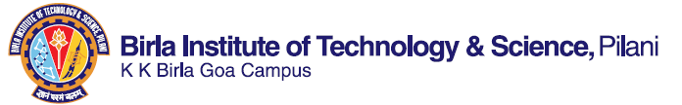
NATIONAL CONFERENCE
ON
NEW FRONTIERS IN CHEMISTRY – FROM FUNDAMENTALS TO APPLICATIONS”
NFCFA 2015, GOA -INDIA
(DEC 18-19, 2015)
Organized by
Department of Chemistry,
Birla Institute of Technology and Science-Pilani
KK Birla Goa Campus, Zuarinagar, Goa-403726
Sponsorship
Platinum sponsorship Rs 75,000/-
One banner inside inauguration hall
One banner at conference venue
One full page color advertisement
Free registration for two participants
Space for booth
Logo on backdrop
Gold sponsorship Rs 50,000/-
One banner inside inauguration hall
One banner at conference venue
One half page color advertisement
Free registration for one participant
Space for booth
Logo on backdrop
Silver sponsorship Rs 30,000/-
One banner inside inauguration hall
One banner inside conference venue
One half page color advertisement
Logo on backdrop
Advertisement rated for abstract booklet
Back cover colored Rs 20,000/-
Inside cover colored Rs 15,000/-
Full page colored Rs 10,000/-
Half-page colored Rs 6,000/- Black and white full page Rs 6,000/-
Black and white half page Rs 4000/-
Black and white quarter page Rs 2000/-
Payments to be made by NEFT (preferred)/Demand Draft in favor of Director, BITS Pilani K. K. Birla Goa Campus, payable at SBI BITS Goa centre.
BANK DETAILS:
RECIPIENT BANK: STATE BANK OF INDIA
Bank Account No: 30803684122
IFS CODE: SBIN0010720
Branch Code: 010720
Name of Account holder: BITS PILANI K. K. BIRLA GOA CAMPUS
Message to be included:
Support for “NFCFA2015”
All sponsors are requested to contact Dr. K. P. Jayadevan (Treasurer) (09049158401)/Mainak Banerjee (convenor) (09604056962).

